Spotify Connect Design documentation

Introduction
Spotify Connect allows users to stream music to (as well as control) hardware/devices from the Spotify app, whether that be on mobile or via the desktop and web player.
The device being used to stream music must be on the same Wi-Fi connection, and if you’re using a mobile device it’ll act as a remote so you can control playback, volume or add other devices to stream to.
Music doesn’t stream from the smartphone to speaker, but instead direct from the Spotify services to the speaker itself, which means your smartphone doesn’t use up any power as it would do if you’re using Bluetooth.
All you need to do is open the app on mobile, desktop or web player, click on the speaker icon at the bottom of the screen and select the device (or devices) that you want to stream to. That means a multi-room setup is possible as you can stream to multiple devices in different rooms.

The RPI-Oradio as spotify connect device
We need to two packages:
- The raspotify package: will turning our Raspberry Pi into a Spotify Connect device.
- The avahi-daemon package: is a free Zero-configuration networking (zeroconf) implementation, including a system for multicast DNS/DNS-SD service discovery.
Spotify uses mDNS to discover endpoints (hence a librespot instance will use mDNS to broadcast itself). By default, librespot uses its own mDNS responder implementation.
Avahi is a system daemon, that does multiple things:
- client: provide name resolution for mDNS services.
- responder: optionally, avahi will also broadcast services records for other programs (typically through dbus)
- It allows programs to publish and discover services and hosts running on a local network with no specific configuration. For example you can plug into a network and instantly find printers to print to, files to look at and people to talk to.

Deployment (Component) view
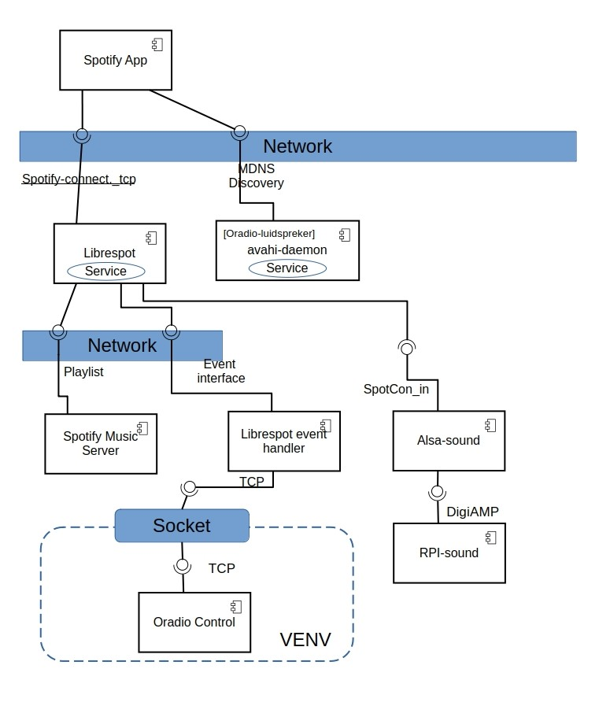
Spotify App
Searches for sound devices using the mDNS Discovery service of avahi-daemon. The Oradio advertises with <Oradio-luidspreker> as sound device.
When a Spotify Connect App (on a phone, tablet, or PC) searches for devices:
It sends a mDNS query for services of type <_spotify-connect._tcp>. The avahi-daemon responds with the registered librespot service.
The Spotify App then lists the Oradio (librespot) as an available device.
Once the Spotify App selects the Oradio:
- It establishes a connection with Librespot using Spotify's authentication and control protocols.
- It sends commands like Play, Pause, Skip, Volume Control.
- Librespot then fetches and plays the audio directly from Spotify servers.
Librespot Service
After receiving a play command, Librespot:
- Authenticates with Spotify servers.
- Retrieves the requested audio stream.
- Decodes and outputs the audio to the Raspberry Pi’s sound card or external DAC.
If Librespot stops or restarts:
- It re-registers itself with avahi-daemon.
- If the Raspberry Pi’s IP address changes:
  - avahi-daemon updates the mDNS records dynamically.

Avahi-daemon:
Librespot uses the avahi-api to publish the Spotify Connect Service.
This service contains metadata (TXT records) such as:
- Device name (e.g., “Oradio-luidspreker” )
- Supported sample rate, bit depth, and codec
- A unique device ID for Spotify authentication

Librespot event handling:
With librespot --onevent=/path/to/my/event/script/program users can subscribe to non-blocking events. The type of script/program you use to handle events is completely up to you, librespot simply runs the script/program every time an event is fired and passes events via environment variables. See for event handling: librespot-events
Alsa-sound:
Alsa-sound offers a sound device to be assigined to Librespot.
pcm.SpotCon_in {
type plug
slave.pcm "SpotCon_VolControl"
}

